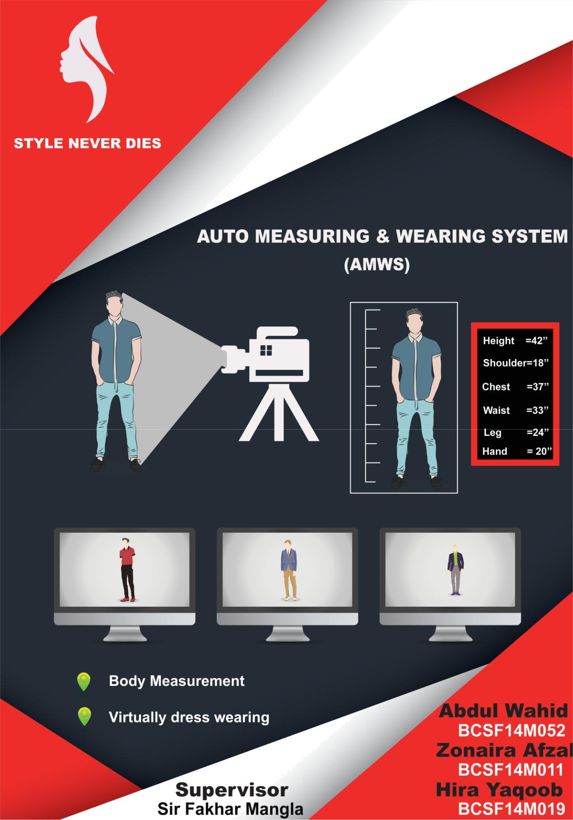
<Version 1>

Project Title:
“Auto Measuring & Wearing system”

Internal Advisor:

Mr. Saad Razaq

External Advisor:
None

Project Manager:

Mr. Fakhar Mangla

Project Team:
Zonaira Afzal (BCCF14M011)

Hira Yaqoob (BCCF14M019)
Abdul-Wahid (BCCF14M052)

Submission Date:

_____________________

Project Manager’s Signature

<Version 1>

Document Information

 | Category |  |  | Information
 | Customer |  |  | UOS
 | Project |  |  | Auto Measuring & Wearing System
 | Document |  |  | Requirement Specifications
 | Document Version |  |  | 1.0
 | Status |  |  | Final
 | Author(s) |  |  | Zonaira Afzal, Hira Yaqoob, Abdul Wahid
 | Approver(s) |  |  | PM
 | Issue Date |  |  | June. 26, 2018
 |  |  |  | 1. | Advisor
 | Distribution |  |  | 2. | PM
 |  |  |  | 3. | Project Office

Definition of Terms, Acronyms and Abbreviations

 | Term |  |  | Description
 | AMWS |  |  | Auto Measuring & Wearing System
 | RS |  |  | Requirements Specifications

Auto Measuring & Wearing System <Version 1>

Table of Contents

CHAPTER 1: SOFTWARE REQUIREMENT SPECIFICATION 7

1. INTRODUCTION 8

1.1 PURPOSE OF DOCUMENT 8

1.2 PROJECT OVERVIEW 8

1.3 SCOPE 8

2 OVERALL SYSTEM DESCRIPTION 8

2.1 USER CHARACTERISTICS 8

2.2 OPERATING ENVIRONMENT 8

2.3 SYSTEM CONSTRAINTS 9

3 EXTERNAL INTERFACE REQUIREMENTS 9

3.1 HARDWARE INTERFACES 9

3.2 SOFTWARE INTERFACES 9

4 FUNCTIONAL REQUIREMENTS 9

5 NON-FUNCTIONAL REQUIREMENTS 10

6 REFERENCES 11

CHAPTER 2: DESIGN DOCUMENT 12

CHAPTER 3: IMPLEMENTATION & INTERFACES 23

CHAPTER 4: TESTING OF AMWS 31

1 INTRODUCTION: 32

2 PURPOSE OF TESTING 32

3 PRODUCT TESTING 32

4 PROCESS OF TESTING 32

5 TESTING TECHNIQUES 32

5.1 Black box testing 32
5.2 White box testing 32

6 IMPLEMENTATION OF TESTING 32

7 UNIT TESTING 33

CHAPTER 5: POSTER 35

CHAPTER 6: PROJECT VIDEO 37

4
CS & IT Department, UOS
Auto Measuring & Wearing System <Version 1>

Table of Figures

Figure 1.1: DFD level 0 13
Figure 1.2: DFD level 1 (AMWS module) 14
Figure 1.3: DFD level 2 (Image Processing) 15
Figure 3: Usecase Diagram 16
Figure 4.1: SD (Dress wearing) 19
Figure 4.2: SD (Measurements calculation) 20
Figure 5: Class Diagram 21

Figure 6: Collaboration Diagram (Measurements & Dress wearing) 22

5
CS & IT Department, UOS
Auto Measuring & Wearing System <Version 1>

ACKNOWLEDGEMENTS

All praises to Almighty ALLAH, the creator of whole universe, the Most Merciful, the Most Beneficent, who gives us light in darkness and help us in difficulties. Whose blessings flourished my thoughts and inspired me to have the fruit of my humble effort in form of this manuscript. After the ALMIGHTY ALLAH, all praises and thanks for the Holy Prophet Muhammad (PBUH) who is forever a torch of guidance and light of knowledge for mankind.

We would like to express our appreciation and my heartiest gratitude to my honorable supervisor, Sir Fakhar Mangla, Assistant Professor in CS & IT Department, University of Sargodha, Sargodha, for his inspiring guidance, constant encouragement, invaluable experience, never ending fount of moral support, endless supervision, and positive criticism during the whole study period.

We would like to give our highest gratitude to our respected adviser Sir Saad, Assistant Professor of CS & IT Department, University of Sargodha, for his constant inspiring leadership and encouragement. We are specially obliged to convey our heartiest thanks to the innovator, and the motivator of our project from the very first step, Sir Abdul Qadeer Lecturer of CS & IT Department, University of Sargodha.

Thanks to all non-teaching staff of CS & IT Department, University of Sargodha, Sargodha, for their assistance during our project.

Zonaira Afzal
Hira Yaqoob
Abdul-Wahid

6
CS & IT Department, UOS
Auto Measuring & Wearing System <Version 1>

Chapter 1: Software Requirement Specification

7
CS & IT Department, UOS
Auto Measuring & Wearing System <Version 1>

- Introduction

1.1 Purpose of Document

This document is explaining all the functionality and basic features of Auto Measuring & Wearing System (AMWS).The document will explain the AMWS to end users that How it will work.

The intended audience are the people of Dress Designing industry, workers of a boutique and customers of that dress shop or boutique etc.

1.2 Project Overview

AMWS consist of three parts. One of these, is High definition camera for capturing customer. Second one is AMWS application that receive pictures from camera and find out the body measurement of customer. As well as AMWS pick the dresses from folder and fit it on the body, according to person’s measurements. Third one is the LCD that displays the customer who is dressed up virtually in different outfits. Goal of AMWS is customer satisfaction and time saving.

1.3 Scope

AMWS will provide the approximate body measurements e.g. height, shoulder length, arm’s length and waist.

AMWS display person who is dressed up virtually in different outfits, on the LCD screen.

- Overall System Description

We develop our system in the lab using Matlab. We are targeting the fashion industry, so it will be deployed on the dress shop, boutique, or malls. The major users are the owner that own our system and the customer that will come and use it. Our software depends upon the camera and the LCD screen. All the data of the customer, and the dresses are managed in separate folders.

2.1 User characteristics

The major users are the dress shop, boutique, or malls’ owner that own our system and the customer that will come and use it. But owners are our direct users and their customers are our indirect user.

2.2 Operating environment

AMWS will be deployed on the boutique or any dress shop. Two hardware component are mandatory for AMWS, camera and LCD. Third component is software which will operate only on the Matlab, installed on Windows operating system (windows 7, 8, 8.1, 10). AMWS will run on the 32-bit (x86) or 64-bit (x64) processor with 4GB or more. It require minimum 16 GB space on the hard disk.

8
CS & IT Department, UOS
Auto Measuring & Wearing System <Version 1>

2.3 System constraints

Some constraints are as follow:

  - Software will only operate on the Windows operating system (windows 7, 8, 8.1, 10). Not supported for mac operating system.

  - High resolution camera is used. Camera resolution must be 25 megapixel or more. Low resolution camera is not supported.
  - English language is supported. Dress types are related to eastern culture.

  - Pictures and the data of the customer is secured. It is not accessed by anyone except operator and customer itself.

  - AMWS deployed in the silent and lighted room for getting clear image. Dark room is not supported.

  - AMWS user should wear a fit dress provided by the shop for clear measurements.

  - AMWS is developed for children, adults, and old person.

- External Interface Requirements

We are using two external device along with our software: LCD and High definition camera.

3.1 Hardware Interfaces

Two hardware components are needed with our software in order to get desired results properly: LCD and High definition camera. The camera is connected to the computer USB port. We attach High definition camera in order to get clear image. We also attach RGB and High pixel displaying LCD in order to display the image on the screen and perform the operations. The major operations includes: capturing image from camera then software will process the image to get measurements, and LCD displays the customer dressed up according to his measurements, and customer’s selection.

3.2 Software Interfaces

Our software uses the stored dresses that are available on the dress shop, where this system is installed. We are designing the software according to windows operating system (7, 8, 8.1, and 10). The exchange of data take place between our software and the storage. We also take the backup of the data so that our data can be retrieve in the case of loss.

4. Functional Requirements

1) Body capturing

System shall take the images from camera.

9
CS & IT Department, UOS
Auto Measuring & Wearing System <Version 1>

2) Measurement calculation

System shall calculate the body measurement of the person through his image.

3) Dress Display

There shall be the display of available dress collection.

4) Dress selection

User can select and change the selection from available dress collection.

5) Dress wearing

System shall fit the selected dress on the person image.

6) Parameters collection

System shall collect the height, choice, and width parameters from the image.

7) Body display

System shall display the image of the person in different dress on LCD.

- System management Operator shall manage the system.

- Data storage

System shall maintain the storage of all the data about the customer and dresses.

5. Non-functional Requirements

5.1 Performance Requirements

AMWS will response quickly even at the time of load and will be reliable for users. The measurements and the dress suggestion shall be precise. It will provide high throughput.

5.2 Safety Requirements

AMWS continuous backup is maintained, so that data can be retrieved in the case of damage or data loss.

5.3 Security Requirements

The images and the data of the person shall not be leaked. It shall be accessible by authorized persons only.

5.4 Approximation
Body measurements shall be approximate.

5.5 Maintainability

AMWS will be easy to maintain in case of any defect and it will be continuously improved.

5.6 Usability
AMWS will be user friendly and easy to use.

5.7 Availability

10
CS & IT Department, UOS
Auto Measuring & Wearing System <Version 1>

AMWS will always be available to its operator.

5.8 Operating constraints
Light, background and operator are the operating constraints.

5.9 Flexibility

AMWS is flexible for changes and we can extend its functionality even after deployment.

5.10 User Documentation

User guide, documentation, and video shall be provided along to software for better user experience.

6 References

We have collected data from different sites and Research papers like:

Sites
Google.com

MathsWork.com

Research papers
Implementation of Real Time Dress-up System based on Image Blending. Fast 3D Model Fitting and Anthropometrics using Single Consumer Depth

Camera and Synthetic Data.
Image-Based Measurement Tools

Segmentation Methods For Multiple Body Parts

Person Body Height Measurement By Using Surveillance Cameras

Determining Three-Dimensional Information From Projections Or Placement Of Two-Dimensional Patterns

Human Body Measurement System In Clothing Using Image Processing

11
CS & IT Department, UOS
Auto Measuring & Wearing System <Version 1>

Chapter 2: Design Document

12
CS & IT Department, UOS
Auto Measuring & Wearing System <Version 1>

- Data Flow Diagram (DFD)

A data flow diagram is a graphical representation of the flow of data through an information system, modelling its process aspects.
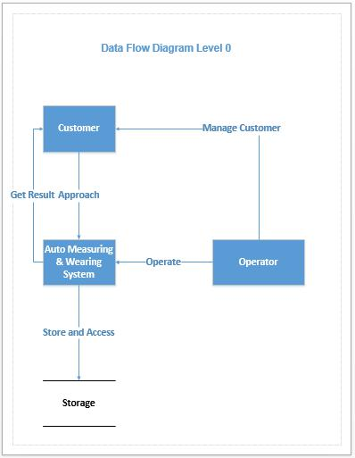

Figure 1.1: DFD level 0

Customer request for using AMWS. Operator get the details of the customer from the receptionist and also operates the AMWS. Storage location is also managed in order to store customer data and dresses.

13
CS & IT Department, UOS
Auto Measuring & Wearing System <Version 1>
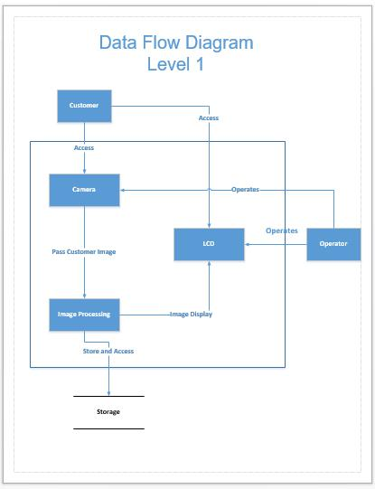

Figure 1.2: DFD level 1 (AMWS module)

Customer stands in the front of camera, image is captured and passed for processing. All the selection and image of the customer is displayed on LCD.

14
CS & IT Department, UOS
Auto Measuring & Wearing System <Version 1>
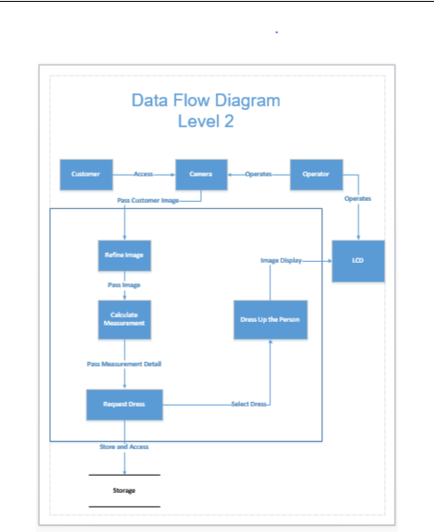

Figure 1.3: DFD level 2 (Image Processing)

Customer image is refined first, the measurements are calculated. Then customer select the dresses from menu and see himself/ herself in that dress virtually.

15
CS & IT Department, UOS
Auto Measuring & Wearing System <Version 1>

- Usecase Diagram

A use case diagram at its simplest is a representation of a user's interaction with the system that shows the relationship between the user and the different use cases in which the user is involved.
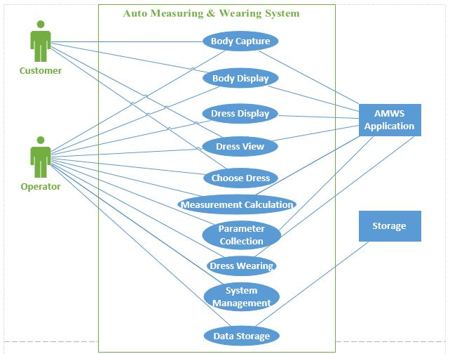

Figure 3: Usecase Diagram

16
CS & IT Department, UOS
Auto Measuring & Wearing System <Version 1>

Usecase

Name | Actor | Pre-condition |  | Main Success |  | Post | Alternative
 |  |  |  | Scenario |  | Condition | Flow
Body | Operator, |  | Background |  | Customer | Image | Invalid
Capturing | Customer |  | of capturing |  | should be | captured | Image:
 |  |  | Scene |  | referred to | successfully | operator
 |  |  | should be |  | Operator. | in required | will capture
 |  |  | White. |  | Customer | pose. | the image
 |  |  | There |  | should stand at |  | again.
 |  |  | should be |  | the fixed
 |  |  | enough |  | capturing
 |  |  | light to take |  | position.
 |  |  | a clear |  | Customer
 |  |  | image. |  | should stand
 |  |  |  |  | according to
 |  |  |  |  | directed pose.
 |  |  |  |  | Operator
 |  |  |  |  | should capture
 |  |  |  |  | the image of
 |  |  |  |  | customer.
Find Body | Operator, | There should |  |  | Operator | Measuremen | Error
Measurements | AMWS | be a valid |  |  | should pass the | ts calculated | Occurred:
 |  | image of |  |  | image to | successfully | Try with a
 |  | customer. |  |  | AMWS. |  | new Image.
 |  |  |  |  | Operator
 |  |  |  |  | should select
 |  |  |  |  | Find
 |  |  |  |  | Measurements
 |  |  |  |  | option from
 |  |  |  |  | menu.
 |  |  |  |  | AMWS should
 |  |  |  |  | process the
 |  |  |  |  | image
 |  |  |  |  | properly.
 |  |  |  |  | AMWS should
 |  |  |  |  | return the
 |  |  |  |  | approximate
 |  |  |  |  | body
 |  |  |  |  | measurements
 |  |  |  |  | of Customer.
Wear Dress | Operator, | There should |  |  | Operator | Dress | Error
 | AMWS, | be pictures of |  |  | should display | wearing done | Occurred:
 |  |  |  |  |  |  | 17
CS & IT Department, UOS

Auto Measuring & Wearing System <Version 1>

 | Customer | some dresses |  | the available | successfully. | Try with a
 |  | available in |  | dresses on |  | different
 |  | storage |  | Screen. |  | target dress.
 |  |  |  | Customer
 |  |  |  | should make
 |  |  |  | selection of
 |  |  |  | dress.
 |  |  |  | Operator
 |  |  |  | should select
 |  |  |  | the part where
 |  |  |  | the dress will
 |  |  |  | be wear.
 |  |  |  | Operator
 |  |  |  | should pass the
 |  |  |  | image of
 |  |  |  | customer and
 |  |  |  | target dress to
 |  |  |  | AMWS.
 |  |  |  | AMWS should
 |  |  |  | process both
 |  |  |  | images
 |  |  |  | properly.
 |  |  |  | AMWS should
 |  |  |  | display the
 |  |  |  | customer
 |  |  |  | wearing target
 |  |  |  | dress.

18
CS & IT Department, UOS
Auto Measuring & Wearing System <Version 1>

- Sequence Diagram

A sequence diagram shows object interactions arranged in time sequence. It depicts the objects and classes involved in the scenario and the sequence of messages exchanged between the objects needed to carry out the functionality of the scenario.
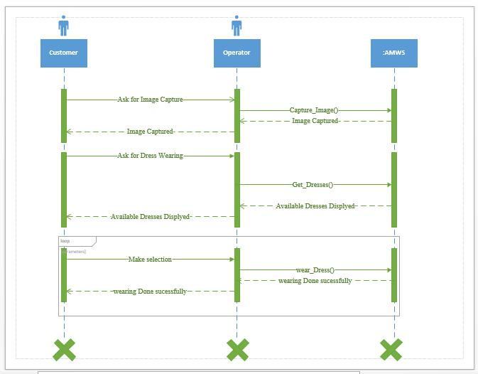

Figure 4.1: SD (Dress wearing)

Customer image is capture from the camera. Customer asks for dresses, & then he/she select the dresses from menu and see himself/ herself in that dress virtually.

19
CS & IT Department, UOS
Auto Measuring & Wearing System <Version 1>
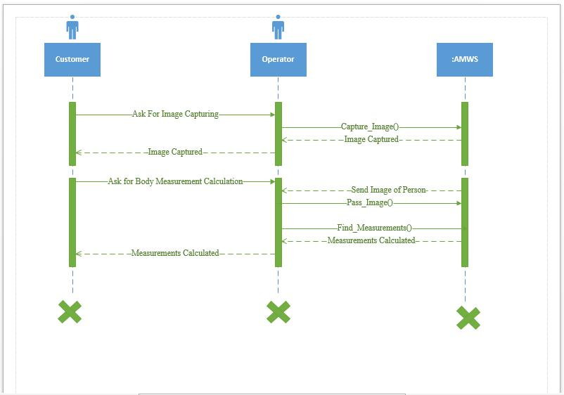

Figure 4.2: SD (Measurements calculation)

Customer image is capture from the camera. He/ She ask for the body measurement calculations through the image. And finally get his/ her body measurements.

20
CS & IT Department, UOS
Auto Measuring & Wearing System <Version 1>

- Class Diagram

A class diagram in the Unified Modeling Language (UML) is a type of static structure diagram that describes the structure of a system by showing the system's classes, their attributes, operations, and the relationships among objects.
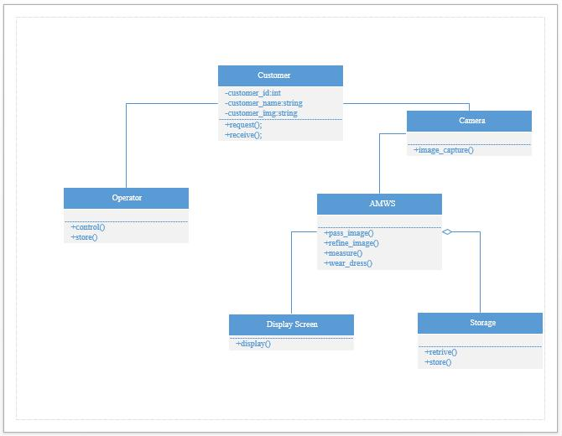

Figure 5: Class Diagram

21
CS & IT Department, UOS
Auto Measuring & Wearing System <Version 1>

- Collaboration Diagram

A collaboration diagram is a type of visual presentation that shows how various software objects interact with each other within an overall IT architecture and how users can benefit from this collaboration.
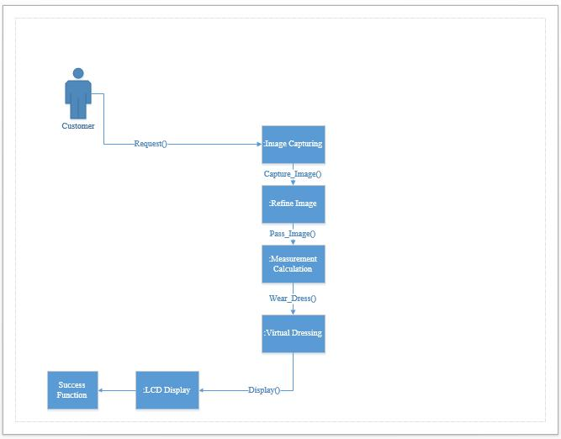

Figure 6: Collaboration Diagram (Measurements & Dress wearing)

Customer image is captured from the camera. He/ She ask for the body measurement calculations through the image. Customer asks for dresses, & then he/ she select the dresses from menu and see himself in that dress virtually.

22
CS & IT Department, UOS
Auto Measuring & Wearing System <Version 1>

Chapter 3: Implementation & Interfaces

23
CS & IT Department, UOS
Auto Measuring & Wearing System <Version 1>

Interface of our software:
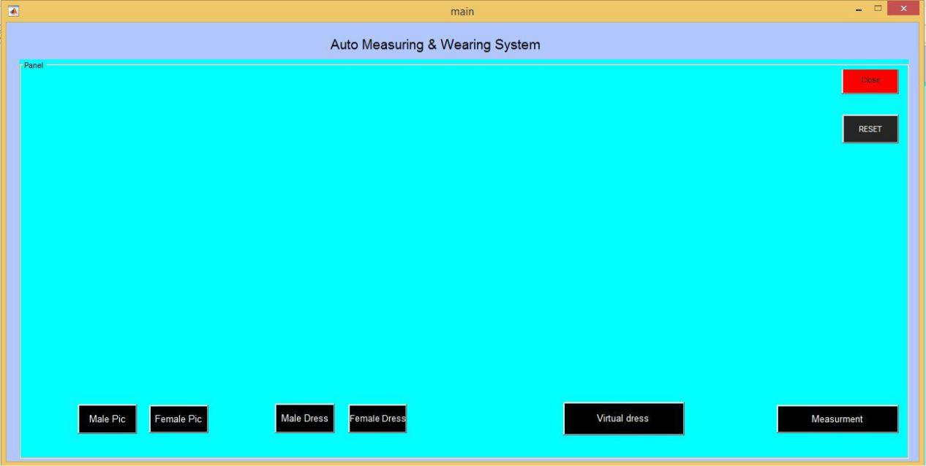

Male person Picture storage:
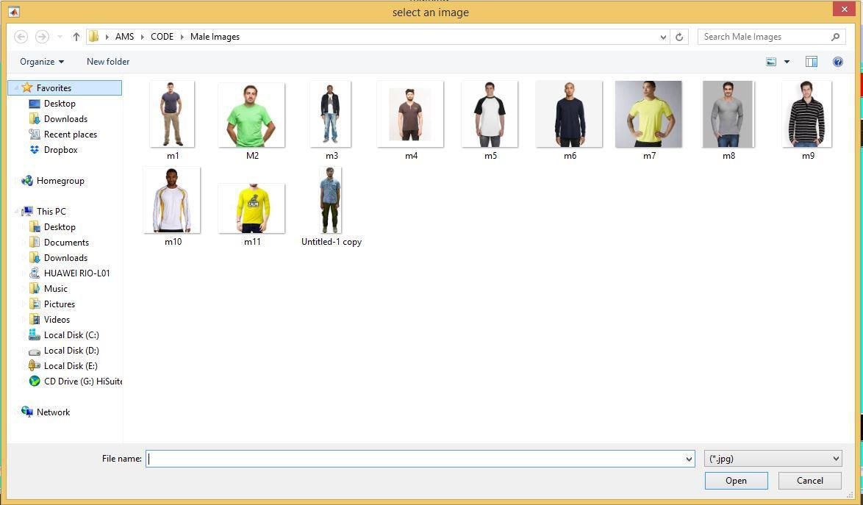

When we capture the image of male person then it is stored in this folder.

24
CS & IT Department, UOS
Auto Measuring & Wearing System <Version 1>

Male person picture Selection:
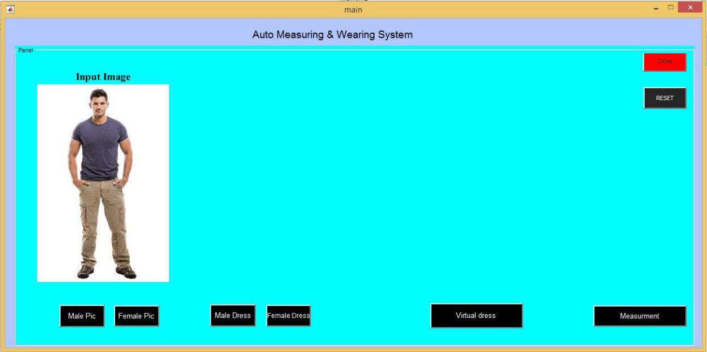

When we click on the male pic button then the male picture storage folder will open, and we can select the desired picture of the person. That picture will be our input image.

Male Dress storage:
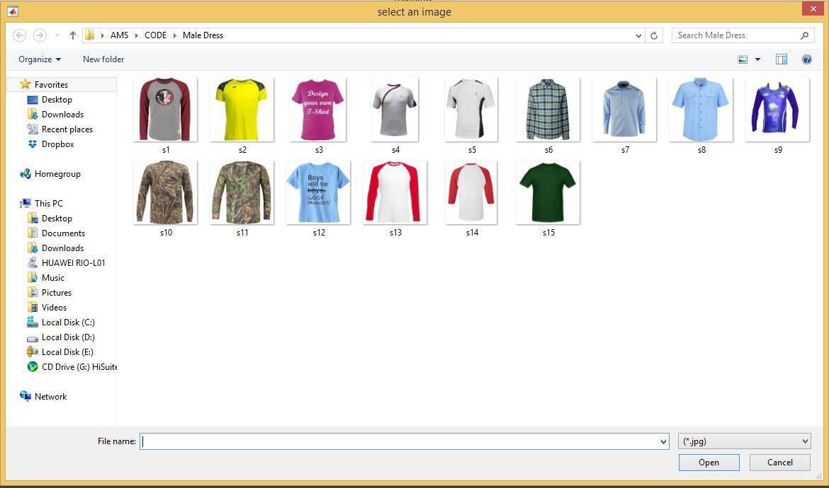

25
CS & IT Department, UOS
Auto Measuring & Wearing System <Version 1>

It is the dress storage of male persons. Any dress can be selected from it in order to wear it on the person virtually.

Male Dress Selection & define region to be wear:
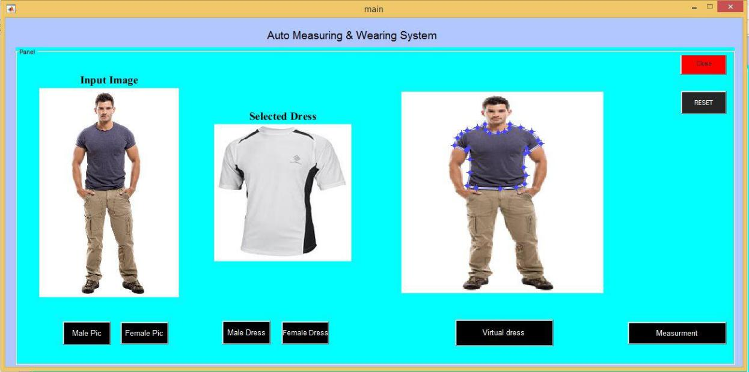

Male dress is selected by clicking on the male dress button. After that we define the region where the dress would be fit on that person. When we click on the virtual dress button then the shirt is wear on the defined region of the person. Like shown below:
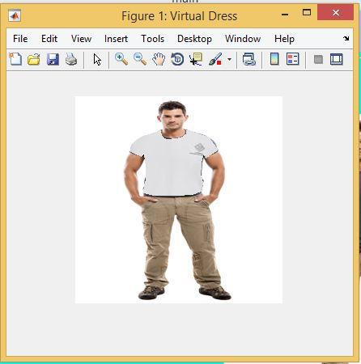

26
CS & IT Department, UOS
Auto Measuring & Wearing System <Version 1>

Female Person Picture Storage
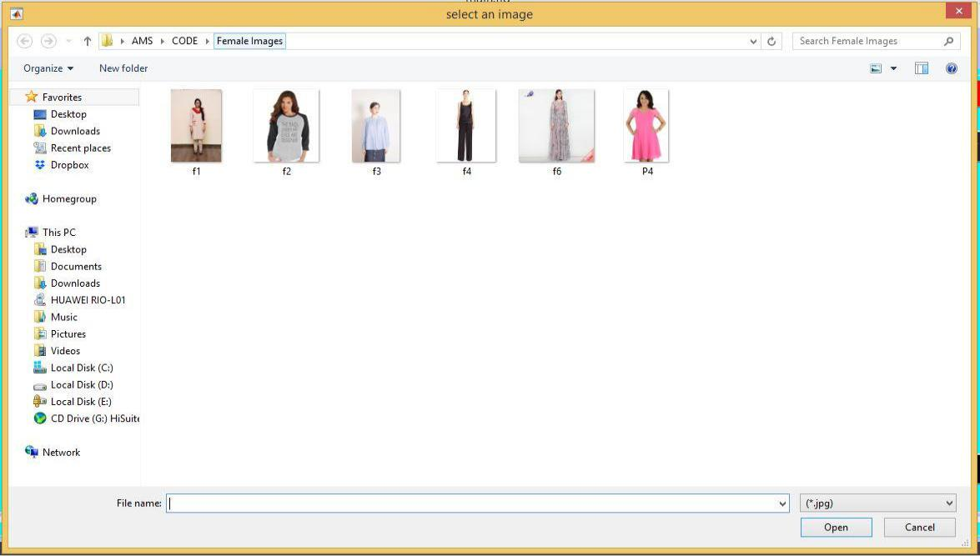

When we capture the image of Female person then it is stored in this folder.

Female person picture Selection:
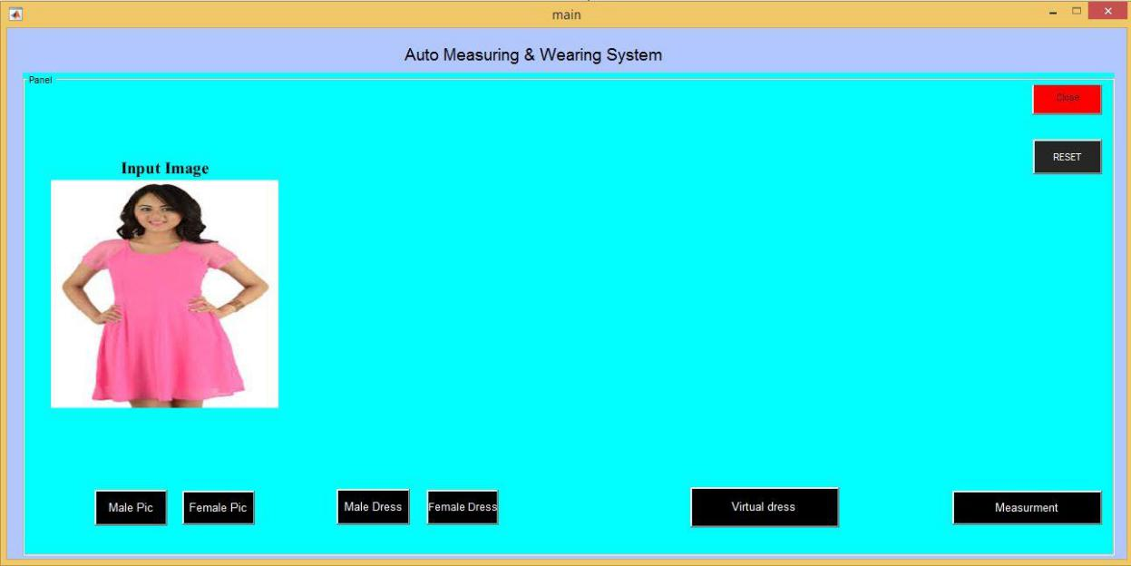

When we click on the Female pic button then the Female picture storage folder will open, and we can select the desired picture of the person. That picture will be our input image.

27
CS & IT Department, UOS
Auto Measuring & Wearing System <Version 1>

Female Dress storage:
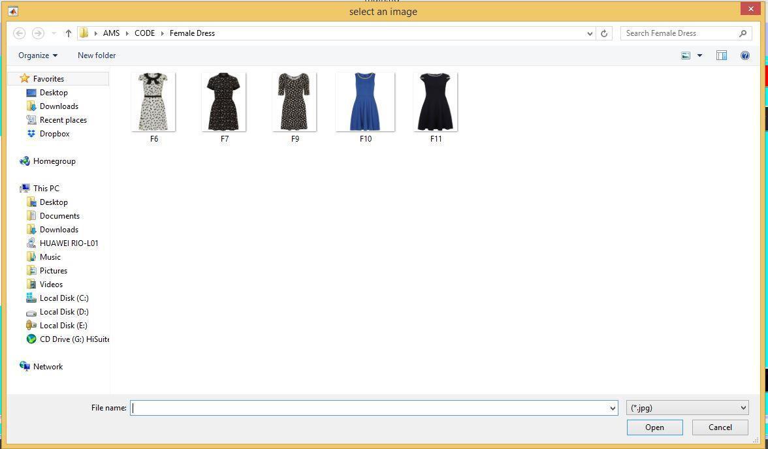

It is the dress storage of female persons. Any dress can be selected from it in order to wear it on the person virtually.

Female Dress Selection & define region to be wear:
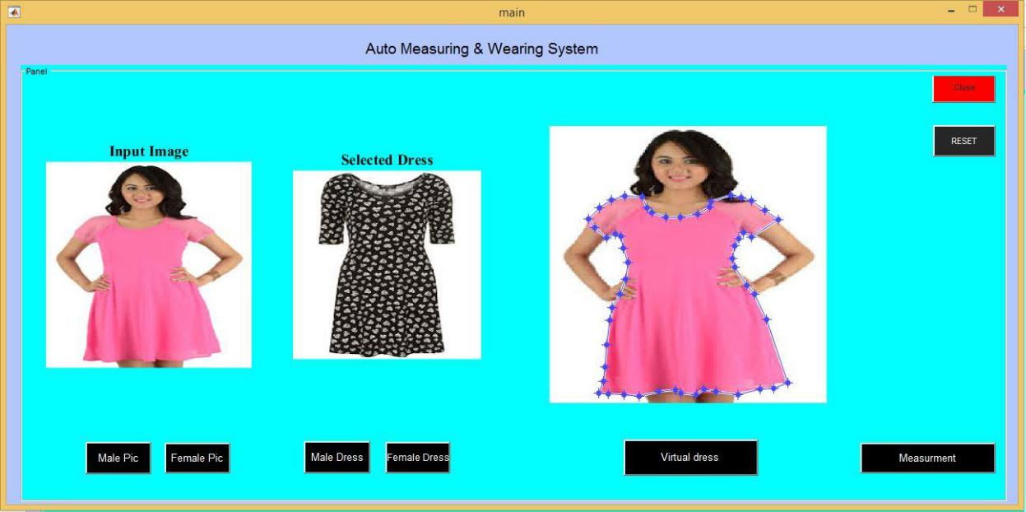

28
CS & IT Department, UOS
Auto Measuring & Wearing System <Version 1>

Female dress is selected by clicking on the male dress button. After that we define the region where the dress would be fit on that person. When we click on the virtual dress button then the dress is wear on the defined region of the person. Like shown below:
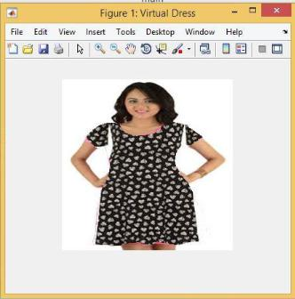

29
CS & IT Department, UOS
Auto Measuring & Wearing System <Version 1>

Body Measurement Calculation:
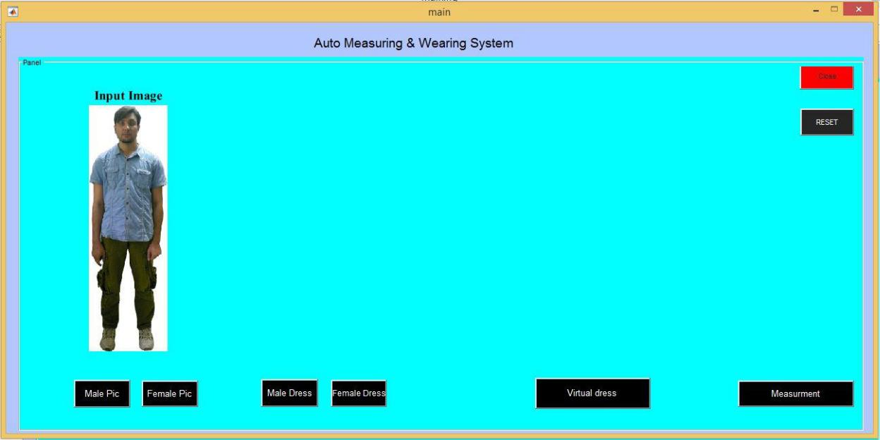

For body measurement, we select the image of the person either it is male and female. Then click on the measurement button to get the measurement of the person. As shown below:
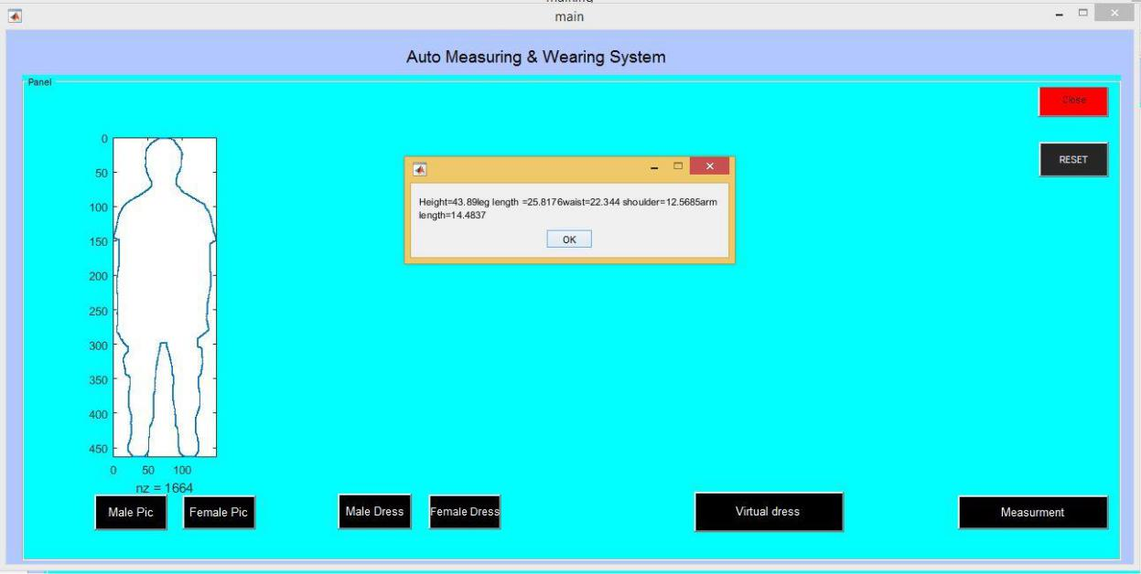

30
CS & IT Department, UOS
Auto Measuring & Wearing System <Version 1>

Chapter 4: Testing of AMWS

31
CS & IT Department, UOS
Auto Measuring & Wearing System <Version 1>

1. Introduction:

This chapter contain the information necessary for the testing, and to verify that all the all the functional requirement of “Skill evaluation and Testing System” are working fine without any error.

2. Purpose of Testing

To check that is the software working exactly the demand and the requirement or not.

3. Product Testing

The project need to be run and explained to end user. We run the project on the computer and device of end user and explained these things.

4. Process of Testing

A process for software test must accommodate low level test that are necessary to verify that small source code segment have been correctly implemented as well as high level functions.

5. Testing Techniques

5.1 Black box testing

Also known as functional testing. A software testing technique whereby the internal workings of the item being tested are not known by the tester. For example, in a black box test on a software design the tester only knows the inputs and what the expected outcomes should be and not how the program arrives at those outputs. The tester does not ever examine the programming code and does not need any further knowledge of the program other than its specifications.

5.2 White box testing

Also known as open box testing. A software testing technique whereby explicit knowledge of the internal workings of the item being tested are used to select the test data. Unlike black box testing, white box testing uses specific knowledge of programming code to examine outputs. The test is accurate only if the tester knows what the program is supposed to do. He or she can then see if the program diverges from its intended goal. White box testing does not account for errors caused by omission, and all visible code must also be readable.

6. Implementation of Testing

Testing of the application is the last most important process in the development of project, testing verifies the application that it is working properly and is able to deliver to user, so user use it in practical environment.

32
CS & IT Department, UOS
Auto Measuring & Wearing System <Version 1>

Following are the different module of project:

7. Unit Testing

Definition:

A testing at the unit level is performed. All modules are tested individually and they are working normally. Expected errors were found and resolved during testing.

Participants:
Zonaira Afzal, Hira Yaqoob, Abdul-Wahid.

Methodology:

Find Measurement Test Case

Test Case ID: |  | ASVFR(tc1) | QA Test Engineer |  | Zonaira Afzal
 |  |  |  |  | Hira Yaqoob
 |  |  |  |  | Abdul-Wahid
Test case |  | Version 1 | Reviewed By |  | Mr. Fakhar Ullah
Version: |  |  |  |  | Mangla
Test Date: |  | Date: May 22 Use Case Reference(s) |  |  | Find Body
 |  | ,2018 |  |  | Measurements Usecase
Revision |  | Nil
History
Objective |  | Ensure the measurements are approximate and match to real world
 |  | calculation.
Environment: |  | Tested after taking measurements through software and then
 |  | matched to real calculated measurements.
Assumptions: |  | User must fulfils the desired constraints.
Pre-Requisite: |  | User should wear tight dress before using the AMWS
Step |  | Execution description |  |  | Procedure result
No.
1. | Approximate body measurements are |  |  | Passed.
 | calculated by the software through image.
Comments
 | Passed
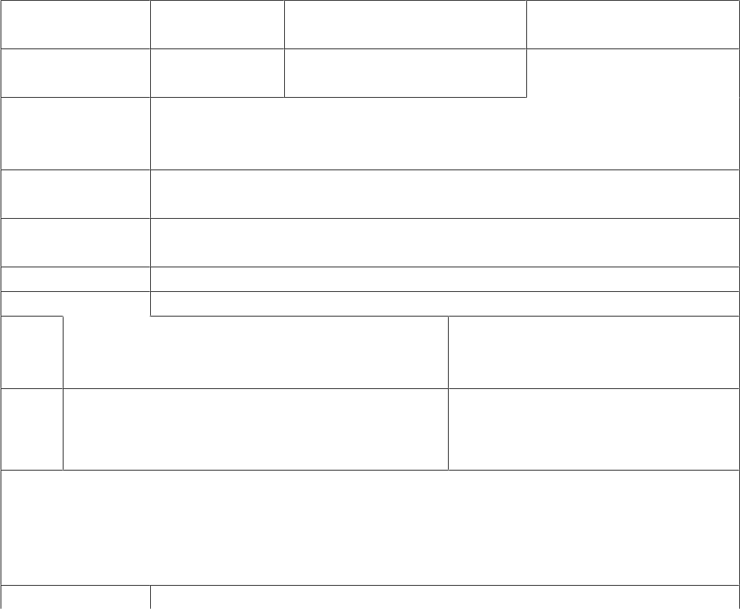

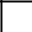Passed Failed 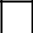Not Executed

33
CS & IT Department, UOS
Auto Measuring & Wearing System <Version 1>

Dress wearing Test Case
Test Case ID: |  | ASVFR(tc1) | QA Test Engineer |  | Zonaira Afzal
 |  |  |  |  | Hira Yaqoob
 |  |  |  |  | Abdul-Wahid
Test case |  | Version 2 | Reviewed By |  | Mr. Fakhar Ullah
Version: |  |  |  |  | Mangla
Test Date: |  | Date: May 22 Use Case Reference(s) |  |  | Wear dress Usecase
 |  | ,2018
Revision |  | Nil
History
Objective |  | Ensure the virtual wearing of the dress on the customer image.
Environment: |  | Tested by viewing the dress on the customer image.
Assumptions: |  | User must fulfils the desired constraints.
Pre-Requisite: |  | User should wear tight dress before using the AMWS.
Step |  | Execution description |  |  | Procedure result
No.
1. | Dress is virtually wear on the image of the |  |  | Passed.
 | user/customer.
Comments
 | Passed
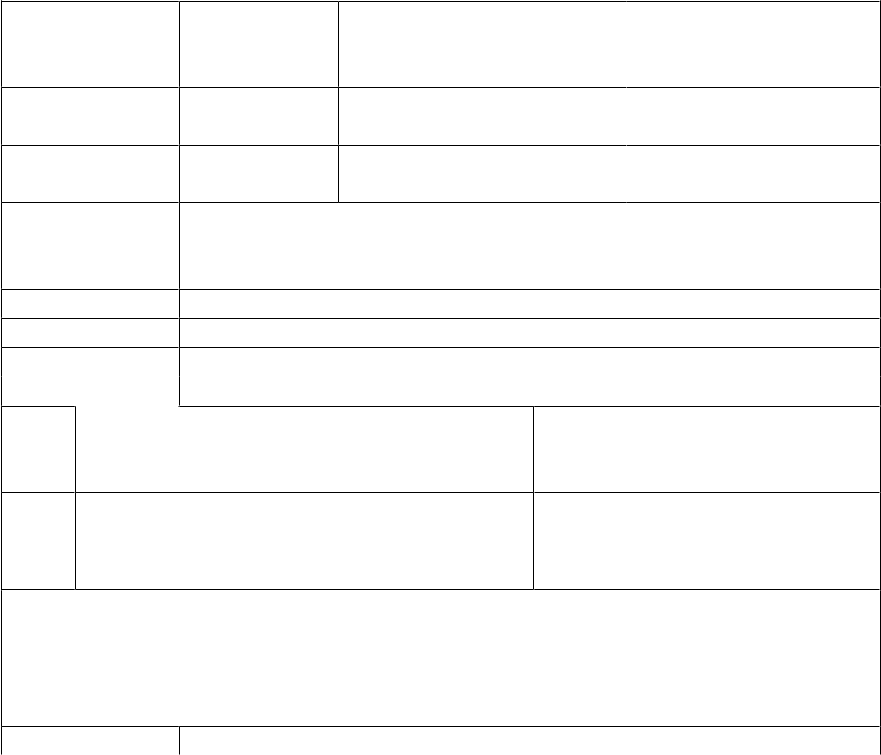

Passed Failed Not Executed

34
CS & IT Department, UOS
Auto Measuring & Wearing System <Version 1>

Chapter 5: Poster

35
CS & IT Department, UOS
Auto Measuring & Wearing System <Version 1>
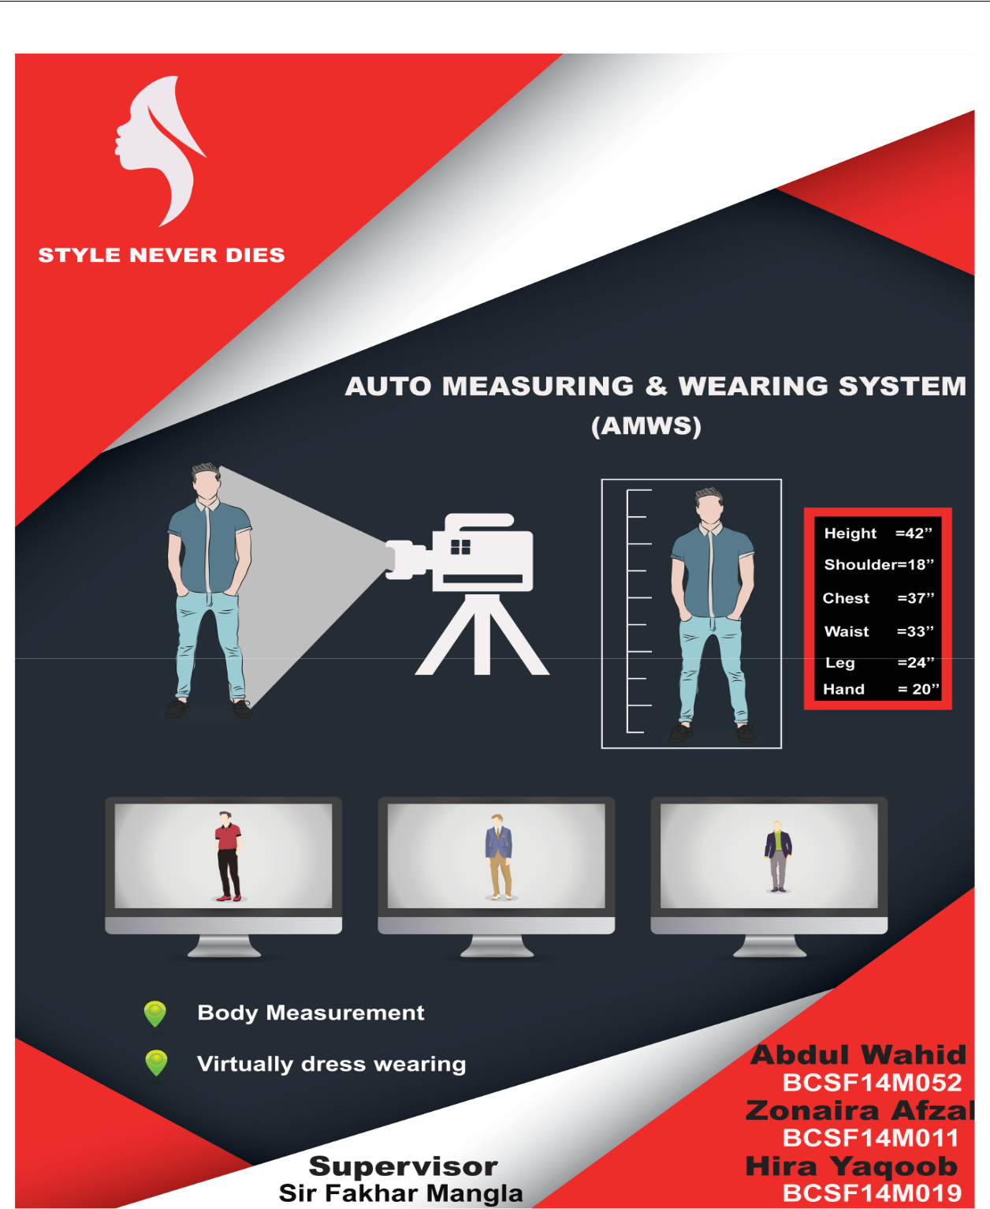

We have made a rough sketch on the paper, discussed with the team member and relevant teachers. We have used Adobe Photoshop & Adobe Illustrator tool for poster designing and shown to our fellows for critical review. For first time the color scheming was not appealing so we have changed the color and the textual representation, and finally presented.

36
CS & IT Department, UOS
Auto Measuring & Wearing System <Version 1>

Chapter 6: Project Video

37
CS & IT Department, UOS
Auto Measuring & Wearing System <Version 1>
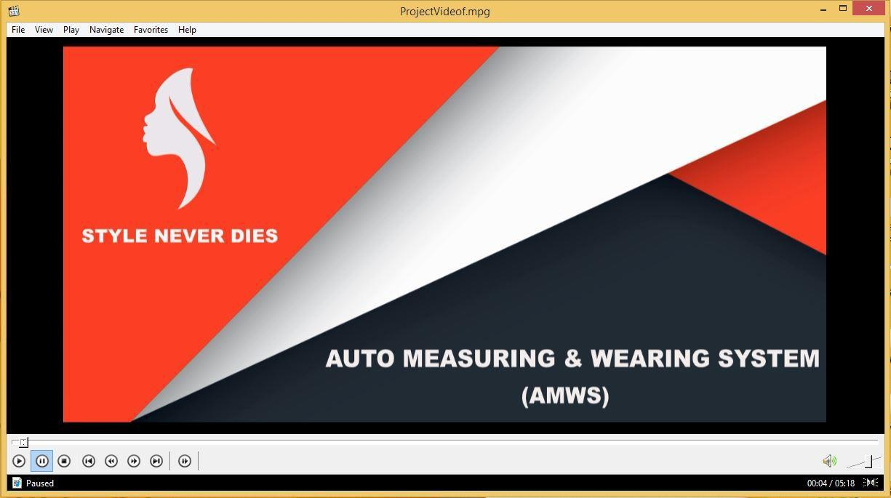

We have created our project video in Ulead software. All the scenes are recorded on individual days. All audio sounds are taken from the internet. We have embedded all the stuff through Ulead software.

38
CS & IT Department, UOS
Auto Measuring & Wearing System <Version 1>

Biography

Zonaira Afzal

Zonaira Afzal is a student of BSCS 8th regular and currently doing her final year project in image processing using Matlab. She belong to Jhang and living in Sargodha for study purposes. Her father is a retired PAF officer, and mother is a teacher. She has 3 siblings, 2 sisters and one brother. All of them are in educational phase. She had passed matriculation with the biological science from Fauji Foundation Model School, Jhang and scored 881/1050 marks, in 2012. She had passed Fsc. Pre engineering from Ghazali science college, Jhang and scored 891/1100, in 2014. Now, she is final semester student of Computer science and her CGPA is 3.40. She is the good player of Badminton.

Hira Yaqoob

Hira Yaqoob is a student of BSCS (8th regular) and working on her final year project which deals with Image Processing. She belongs to Bhakkar city and currently living in Sargodha to complete her graduation. Her father is a farmer, and mother is a housewife. She had done matric in Computer Science from Govt. Girls High School Mankera, Bhakkar and secured 864/1050 marks, in 2012. She had studied ICS from Superior College Bhakkar and secured 868/1100 marks. Now, she is final semester student of Computer science and has 3.45 CGPA. She likes to spend her spare time with her family and loves book reading.

Abdul Wahid Afridi

Abdul Wahid Afridi belongs to West area Fata Khyber Agency. He reflect a varied personality including ambition, and the qualities of generosity and thoughtfulness. He is also a well determined and vigorous individual, yet pleasantly calm. He has 5 siblings (four sisters and one brother). His brother is in educational phase. He is a full-time student, motivated by my love for learning and succeeding. Through his passion for performing, he embraced as a comparer in a cultural program as well as educational program. Many of them as a regional, while being rewarded the Best Talent award in each. As he belong from illiterate area so he had passed Matric from Peshawar zone near to Khyber Agency, and scored 863/1050. He had passed Fsc. Pre engineering from Government College of Peshawar and scored 850/1100. Now he is final year student of Computer Science & carrying out his final year project in image processing using Matlab.

39
CS & IT Department, UOS

